**I have lots of data in our University REDCap instance, how do I integrate the two systems?**

Is it a one time integration (migrating data from REDCap to DHIS2) or you would like to have on-going integration.

High-level steps coming to my mind is:

**Learn DHIS2 API**

**Learn REDCap API**

Create a **DHIS2 dataset for the data elements you want to extract from REDCap**

Implement an extract-transform-load logic (if it’s one time python/js scripts may do) using apis of both. If it’s ongoing integration, may be you shall use advanced tools like apache-camel suggested by dhis2 core developers.

LOGIN : <https://redcap.uits.iu.edu/index.php>

IU REDCAP : <https://servicenow.iu.edu/kb?id=kb_article_view&sysparm_article=KB0023570#login>

<https://servicenow.iu.edu/kb?id=kb_article_view&sysparm_article=KB0023570>

**API REDCAP :** [**https://www.youtube.com/watch?v=S3yNJWfFo8A**](https://www.youtube.com/watch?v=S3yNJWfFo8A)

**DHIS2 API**

[**https://www.youtube.com/watch?v=nPh9UVsFGPw&t=1s**](https://www.youtube.com/watch?v=nPh9UVsFGPw&t=1s)

**DHIS2 to PowerBI Connector**

**[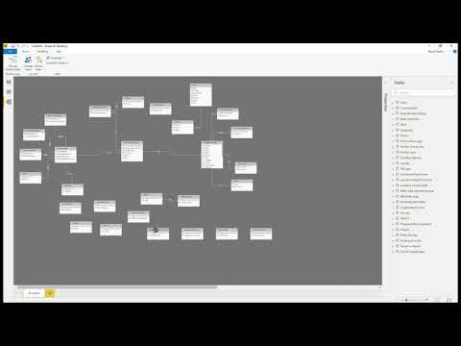](https://www.youtube.com/embed/GBXe6uWUGWM?feature=oembed)**

**DHIS2 API DOCUMENTATION**

[**https://docs.dhis2.org/en/develop/using-the-api/dhis-core-version-239/introduction.html**](https://docs.dhis2.org/en/develop/using-the-api/dhis-core-version-239/introduction.html)